Name: ALA-AN, PRINCESS BEVERLY R.
Section: BN01 Date: August 9, 2025
Course: PROGRAMMING LANGUAGES

- Give more strings in L aside from w = 01010101. Reg Exp for L = (01)*+(10)*+0(10)*+1(01)*
1. 1010101010 matches (10)*
2. 0101010 matches 0(10)*
3. 101010101 matches 1(01)*
4. “” matches (01)*+(10)*+0(10)*+1(01)*
5. 0101 matches (01)*
6. 1010 matches (10)*
7. 010 matches 0(10)*
8. 101 matches 1(01)*
9. 1 matches 1(01)*
10. 0 matches 0(10)*

- RE = 1*00*1(0+1)*
Task:
    - Construct one full valid string that matches the regular expression by explicitly applying each operator ({*}, {+}).
      - Indicate clearly which parts of the regular expression.
Answer: 11100111
where:
111 matches 1* in 1*00*1(0+1)*
0 matches 0 in 1*00*1(0+1)*
0 matches 0* in 1*00*1(0+1)*
1 matches 1 in 1*00*1(0+1)*
11 matches 1* in 1*00*1(0+1)*
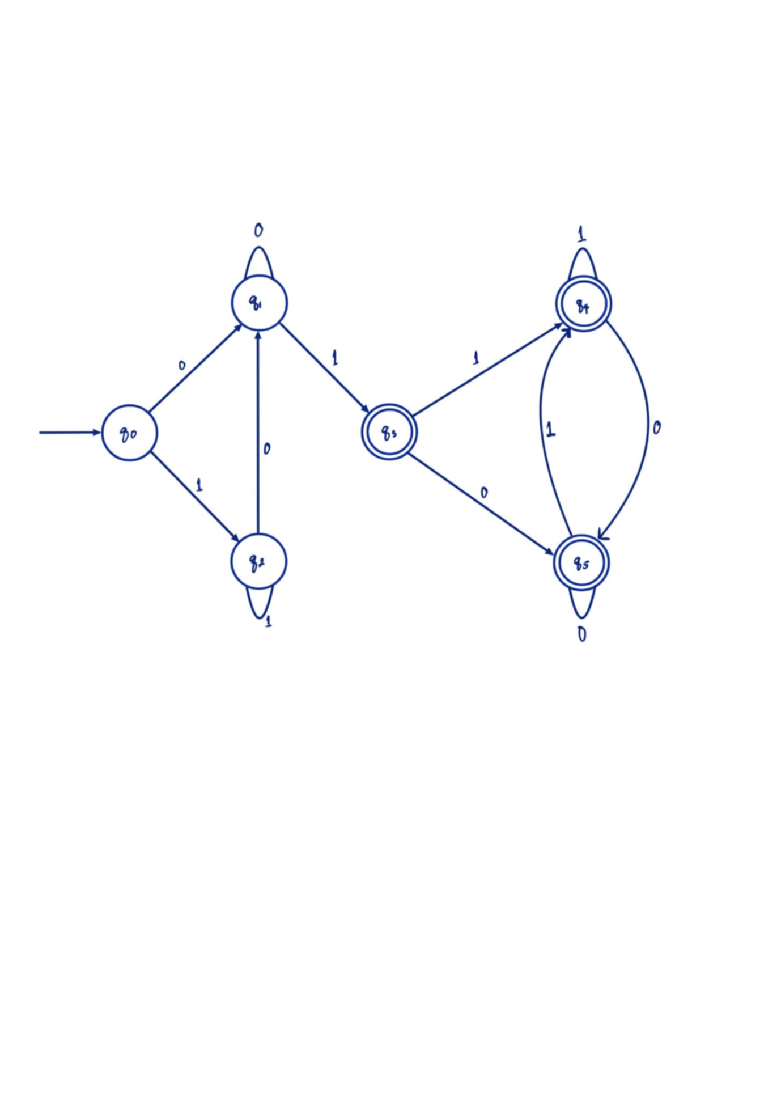
    - Draw the DFA that accepts the same string:
      - Label all states and transitions,
      - Identify the start and accepting state(s),
State/Input | 0 | 1
->q₀ | q₁ | q₂
q₁ | q₁ | *q₃
q₂ | q₁ | q₂
*q₃ | *q₅ | *q₄
*q₄ | *q₅ | *q₄
*q₅ | *q₅ | *q₄
q₀ is the starting state.
*q₃, *q₄, and *q₅ are the accepting states.

      - Make sure the DFA accepts the constructed string in Question #1
Transition Equation Guide:
δ(current state, input symbol) = next state
String: 11100111
δ(q₀, 1) = q₂
δ(q₂, 1) = q₂
δ(q₂, 1) = q₂
δ(q₀, 0) = q₁
δ(q₀, 0) = q₁
δ(q₀, 1) = q₃
δ(q₅, 1) = q₅
δ(q₅, 1) = q₅

The string 11100111 is a valid string and is accepted by the DFA.

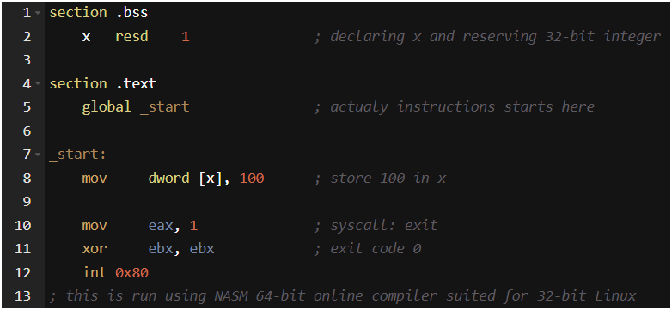
- Machine Code Translation Task
Based on the sample CFG production rules presented in the project, consider the context-free language that generates the following variable declaration and assignment:
x: int
x = 100
Task: Write the equivalent machine-level code for this statement using an assembly language of your choice (e.g., x86, MIPS, or ARM), based on your understanding of instruction-level representation from your Computer Architecture and Organization course.

